EXCRETION

WHAT IS EXCRETION?

Excretion is the process by which metabolic waste products and toxic materials are removed from the body of an organism.

Metabolic waste products are formed from all the anabolic and catabolic activities taking place in the body.

Catabolic activities are the chemical processes taking place in the body in which breakdown of complex substances into simpler substances occurs.

Whereas, anabolic activities are chemical processes in which simpler substances join together to form more complex substances.

We must be able to distinguish between egestion and excretion. Egestion is the removal of undigested matter from the alimentary canal.

Metabolic processes produce waste products which can be harmful if allowed to accumulate in the body. Therefore they must be removed for the safety of the body.

In the animal kingdom, several excretory devices have evolved. In most unicellular organisms, the simplest way is to discharge the excretory products by diffusion into the surrounding water. Whereas in larger unicellular organisms, several organs are involved which work collectively to excrete the harmful products from the body.

EXCRETION IN MAMMALS

The major excretory products and their excretory organs are stated below.

- Carbon dioxide, a gas in the expired area is excreted by the lungs.
- Nitrogenous chemical substances are excreted by the kidneys as constituents of urine and the skin as constituents of sweat but in a very small quantity. These substances mainly include urea (produced from the deamination of proteins), creatinine (from muscle breakdown) and uric acid ( breakdown of nucler substances).
- Excess water is removed from the kidneys as a main constituent of urine, from the skin as the main constituent of sweat and the lungs as water vapour in expired air.
- Bile pigments (from haemoglobin breakdown), is excreted from the liver via the intestines.

We will study the functions of kidney in detail in this chapter. Functions of skin and lungs are discussed in other chapters

THE MAMMALIAN URINARY SYSTEM

The urinary system of a mammal consists of a pair of kidneys, a pair of ureters, a urinary bladder and urethra.

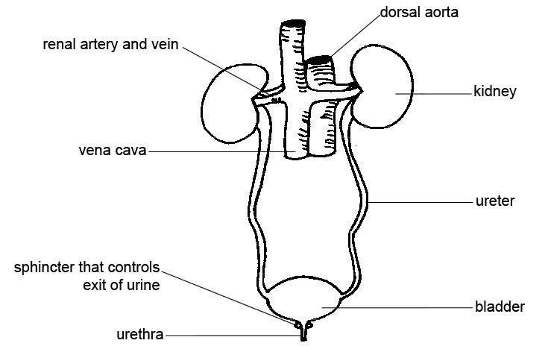

The kidneys of a mammal are bean shaped. The concave surface of each kidney faces the vertebral column. At the centre of this surface, is a depression, the hilus, where the renal artery, the renal vein and nerves are connected to the kidney. From the hilus, a narrow tube, the ureter emerges and travels downward to join the dorsal surface of the urinary bladder. The bladder is an elastic, muscular bag, ventral to the rectum. It stores urine.at the bottom of the bladder is a sphincter muscle. When the bladder is full, the sphincter muscle relaxes to allow the urine to flow into the urethra and pass out of the body.

LONGITUDAL SECTION OF A KIDNEY

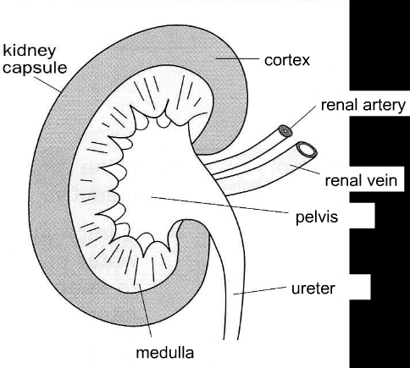

The diagram above shows that the mammalian kidney consists of two main regions

- An outer, darker region called the cortex.
- An inner thicker region, paler in color, known as the medulla. In man and most large mammals the medulla consists of 12-16 conical structures, the pyramids, projecting into a funnel like space in the kidney called the renal pelvis.

The renal pelvis is the enlarged portion of the ureter inside the kidney. The medulla pyramids possess numerous uriniferous tubules which are also known as nephrons. These are the tubules where urine is formed.

THE STRUCTURE OF A NEPHRON

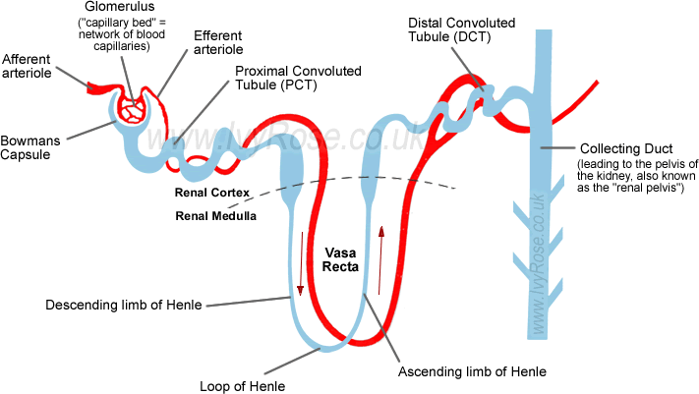

There are two parts of a kidney nephron: the renal corpuscle, and the renal tubule.

(1) Renal Corpuscle
The renal corpuscle is the part of the kidney nephron in which blood plasma is filtered.
The term "corpuscle" means "tiny" or "small" body. The renal corpuscle of each kidney nephron has two parts - they are the Glomerulus, which is a network of small blood vessels called capillaries, and the Bowman's Capsule(also known as the Glomerular Capsule), which is the double-walled epithelial cup within which the glomerulus is contained.
Within the glomerulus are glomerular capillaries that are located between the afferent arteriole bringing blood into the glomerulus and the efferent arteriole draining blood away from the glomerulus. The (outgoing) efferent arteriole has a smaller diameter than the (incoming) afferent arteriole. This difference in arteriole diameters helps to raise the blood pressure in the glomerulus.

The area between the double-walls of the Bowman's Capsule is called the capsular space. The cells that form the outer edges of the glomerulus form close attachments to the cells of the inner surface of the Bowman's Capsule. This combination of cells adhered to each other forms a filtration membrane that enables water and solutes (substances that are dissolved in the water/blood) to pass through the first wall of the Bowman's Capsule into the capsular space. This filtration process is helped by the raised blood pressure in the glomerulus - due to the difference in diameter of the afferent and efferent arterioles.

So to summarise:
In the renal corpuscle blood is forced through the glomerular capillaries at higher pressure than the pressure at which the blood generally travels around the body (and also into the kidney itself). Helped by the increased pressure in the glomerular capillaries, a filtration process occurs in which some blood fluid is forced out of the glomerulus and into the capsular space of the Bowman's Capsule.
The fluid that is filtered into the Bowman's Capsule is called the glomerular filtrate.

(2) Renal Tubule
The renal tubule is the part of the kidney nephron into which the glomerular filtrate passes after it has reached the Bowman's capsule. The first part of the renal tubule is called the proximal convoluted tubule (PCT), which is shown on the right-hand side of the diagram above.
The water and solutes that have passed through the proximal convoluted tubule (PCT) enter the Loop of Henle, which consists of two portions - first the descending limb of Henle, then the ascending limb of Henle. In order to pass through the Loop of Henle, the water (and substances dissolved in it) pass from the renal cortex into the renal medulla, then back to the renal cortex. When this fluid returns to the renal cortex (via the ascending limb of Henle) it passes into the distal convoluted tubule (DCT), which is shown on the left-hand side of the diagram above.
The distal convoluted tubules of many individual kidney nephrons converge onto a single collecting duct. The fluid that has passed through the distal convoluted tubules is drained into the collecting duct (far left-hand-side of the diagram above). Many collecting ducts join together to form several hundred papillary ducts. At each renal papilla the contents of the papillary ducts drain into the minor calces –
the channels through which the fluid passes, via the major calyx, into the centre of the kidney - called therenal pelvis.

THE FORMATION OF URINE

Two main processes are involved in the formation of urine within each tubule.

- Ultrafiltration:
This is a simple mechanical process in which due to the high hydrostatic pressure in the glomeruli, ultrafiltration occurs through the very fine pores of the filters in the malpighian corpuscles. The filtrate that enters the renal capsule has the same composition as tissue fluid. It contains water as its main constituent along with: mineral salts, glucose, amino acids and nitrogenuous waste products.

- Selective Reabsorption:
A large amount of filtrate is formed in the renal capsule but over 99 percent of it is reabsorbed from the first convoluted tubule and loop of henle, mainly by osmosis and active transport. Selective reabsorption takes place because the filtrate contains some elements which are very useful for the body including water, glucose, amino acids and mineral salts. Therefore these products are reabsorbed selectively and excess water, mineral salts and nitrogenuous waste products are allowed to pass along the nephron and out through the collecting tubule into the renal pelvis as urine.

THE NORMAL CONSTITUENTS OF URINE

The composition of normal urine varies considerably depending on several factors. For instance, taking a protein rich diet will result in more urea being present in the urine. Even sugar can appear in the urine after a heavy intake. Similarly larger intake of liquids and water rich foods will increase the volume of water in the blood.

Abnormal constituents of urine are found in certain diseases. For example, in diabetes mellitus, the urine contains a considerable amount of glucose. This happens because the body is unable to store excess glucose in the form of glycogen. This may be due to the inability of the pancreas to secrete insulin. Insulin is the hormone needed by the liver to convert glucose to glycogen.

THE KIDNEYS AS OSMOREGULATORS

Osmoregulation is the control of water and solute levelsin the blood to maintain a constant water potential in the body.

The water potential of the blood has to be kept constant. Drastic changes in the water potential can bring about serious consequences. For instance, if the blood plasma becomes too dilute, the blood cells will swell and burst. And if it becomes too concentrated, osmosis will cause the blood cells and tissue cells to shrink and become dehydrated.

The water potential of the blood depends on the amount of water and salts in the plasma. The water content of the blood is controlled by the vasopressin or anti-diuretic hormone (ADH). It is produced by the pituitary gland and increases water reabsorption by the kidney tubules.

- Course of action if the blood plasma is too concentrated:

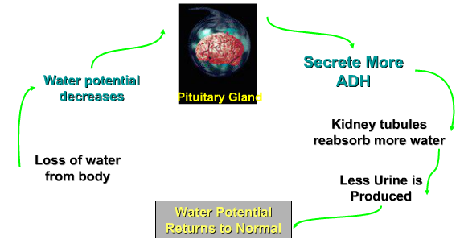

- Course of action if the blood plasma is too dilute:

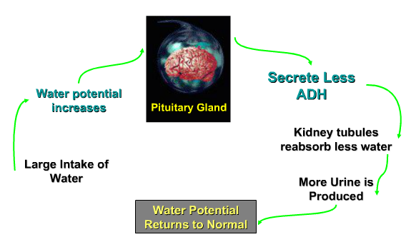

KIDNEY FAILURE

Kidney failure can be caused by :
- Diabetes
- Hypertension
- Inherited kidney disease
- Kidney stones
- Infections
- Drug abuse.

If a person’s kidney fails, he can still lead a normal life, but if both hid kidney’s fail, there is no chance of survival. Therefore the infected person will have to undergo dialysis, a medical procedure, in which the harmful substances are excrete from the body by using a dialysis machine.

DIALYSIS

- THE DIALYSIS MACHINE:

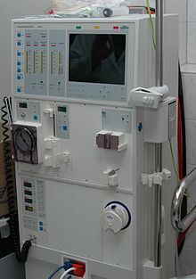

A dialysis machine is also known as an artificial kidney. It is used to cleanse the blood of a person whose kidneys do not work. It eliminates the nitrogenous waste products and excess water from the body.

- HOW A DIALYSIS MACHINE WORKS:
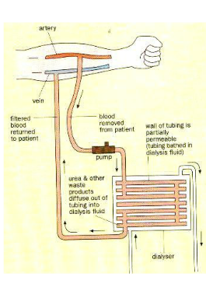

Blood is drawn from an artery in the patient’s arm and is allowed to flow through the tubing in the dialysis machine. The tubing is bathed in a specially controlled dialysis fluid. The walls of the tubing are partially permeable. They allow small molecules, like urea and other waste products, to diffuse out of the tubing into the dialysis fluid. Big molecules, like proteins and blood cells, remain in the tubing. This process is called dialysis.

Dialysis fluid contains essential salts for the body. This ensures that that such salts do not diffuse out of the blood. Moreover, if the blood lack such salts, these salts will diffuse into the blood. The tube is narrow, long and coiled to increase the surface area to volume ratio. This speeds up the rate of exchange of substances between the blood and dialysis fluid. The direction of blood flow is opposite to that of the dialysis fluid. This maintains the diffusion gradient for removal of waste products. The filtered blood is then returned to a vein in the patient’s arm. The patient needs to be treated about 2 to 3 times a week. Each treatment takes several hours.

